DURATION: 2 Hours

THEORIC CONTENTS

* **Lesson 3.** Data Types.
* **Lesson 4.** Operators and Expressions.

LEARNING OBJECTIVES

* **LO-02.1.** Identify the Variables that are required in algorithm design.
* **LO-02.2.** Identify the Constants that are required in algorithm design.
* **LO-03.1.** Choose correctly the data type of a variable according to the values that it could store in algorithm design.
* **LO-03.2.** Choose correctly the data type of a constant according to the values that it could store in algorithm design.
* **LO-05.1.** Implement variables in C language in function of the type and range of values that is needed in the design of a given algorithm.
* **LO-05.2.** Implement variables in C language in function of the type and range of values that is needed in the design of a given algorithm.
* **LO-06.1.** Implement basic input operations in C language to collect and show data thorught variables.
* **LO-06.2.** Implement basic output operations in C language to collect and show data thorught variables.
* **LO-07.1.** Implement basic input operations in C language to collect and show data throught variables.
* **LO-07.2.** Implement basic output operations in C language to collect and show data throught variables.
* **LO-10.1.** Define and Evaluate expressions, considering values, variables, constants and precedence rules and order of evaluation of each operator.
* **LO-11.1.** Implement in C Language expressions using arithmetic and assignment operators.

GITHUB CLASSROOM ASSIGNMENT

**https://classroom.github.com/a/MXtKWHb2**

PROPOSED EXERCISES

Exercise 1. Design and implement a C program that request to the user his Name (It has to be a single name), age (number of years) and weight (kilograms including decimals), and it shows all data on screen.

Examples of expected output:

Example 1:

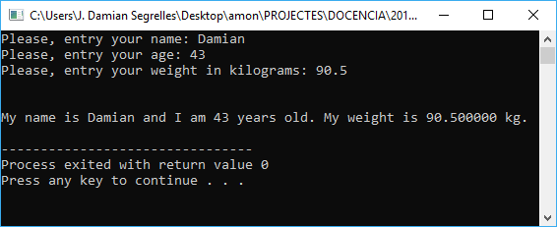

Example 2:

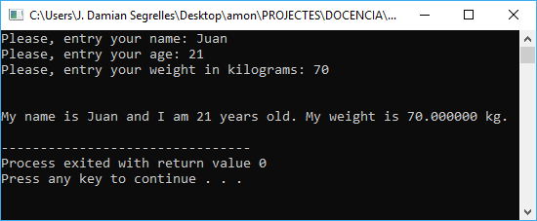

Exercise 2. Design and implement a C program that read this information:

* + Your Name. It has to be a single name. (Ex. “Damian”).
  + First Surname. It has to be a single first surname. (Ex. “Segrelles”).
  + Second Surname. It has to be a single second surname. (Ex. “Quilis”).
  + NIF. It has been composed by a number and one letter. (ex. “48285791M”).
  + Birthdate. It has to be composed by three number which corresponds to the day, month and year respectively. (ex. “01 12 2009”).
  + Sex (F/M). It has to be composed of only one character. (ex. ‘F’)

Finally, the program will show all introduced information on screen.

Examples of expected output:

Example 1:

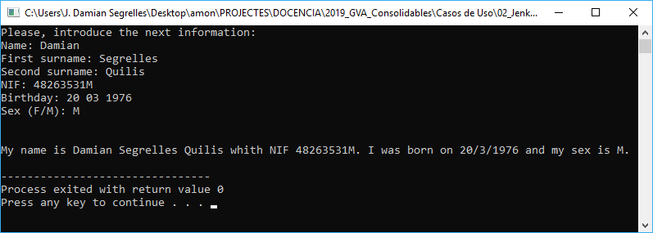

Example 2:

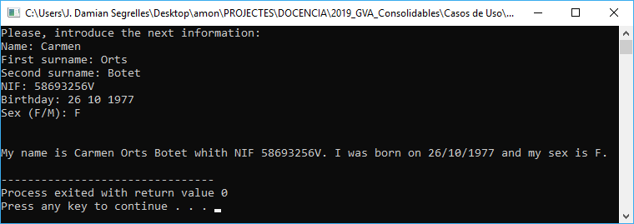

Exercise 3. Design and implement a C program that calculates the area and perimeter of a circle based on a radius given by the user.

**NOTE:** PI number should be considered as the fixed value 3.14159 and the radius have to be a real number.

Examples of expected output:

Example 1:

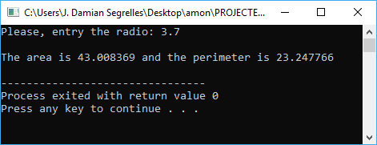

Example 2:

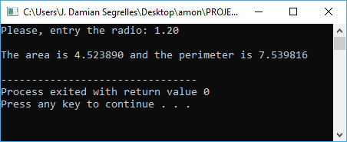

Exercise 4. Design and implement a C program that solves the next problem definition:

A car parts company needs a program that computes and displays the selling price (Euros) of its products. In this sense, the program should apply the following formula:

The cost price and the profit margin are specified by the user. The program should read such values from keyword and then, it should compute the selling price. The result should be displayed on the screen.

**NOTE:** The cost price has to be composed by a number that corresponds to euros and cents, and the profit margin the percentage without decimal part.

Examples of expected output:

Example 1:

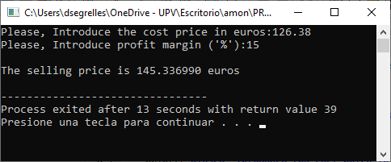

Example 2:



Exercise 5. Design and implement a C program that solves the next problem definition:

In the ETSID, every year are brought agendas for its students. The provider sells boxes of different size or single agendas. The size of the boxes is the follow:

* Big box with 50 units.
* Medium box with 20 units.
* Small box with 5 units.
* Individual units.

When bigger is the box, this is cheaper.

The program has to request to the user the number of agendas that the ETSID wants to buy and compute number of boxes (big, medium, small) and individual agendas that supposes for the ETSID the minimum cost.

**NOTE:** The size of the boxes should be considered as a fixed value.

Examples of expected output:

Example 1:

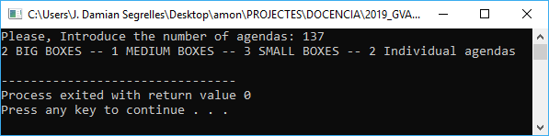

Example 2:

